Practical no.1: MongoDB Basics

A] Write a MongoDB query to create and drop database.

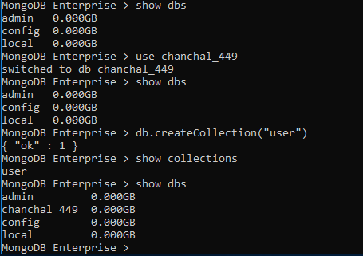

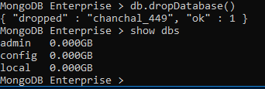

B] Write a MongoDB query to create, display and drop collection.

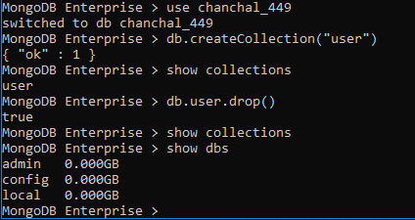

C] Write a MongoDB query to insert, read ,update and delete a document.

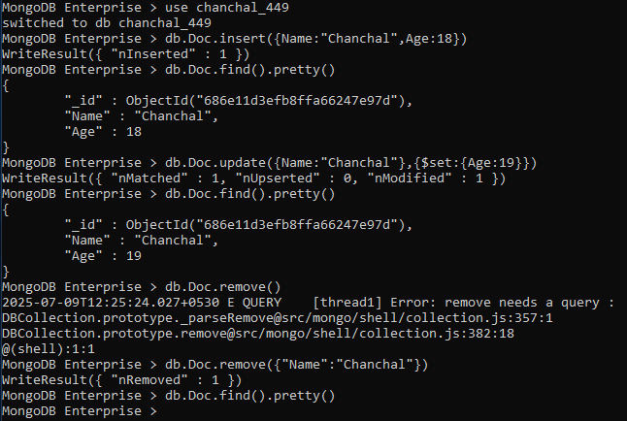

D] Employee Queries

1) Insert and display the documents in Employee collection.

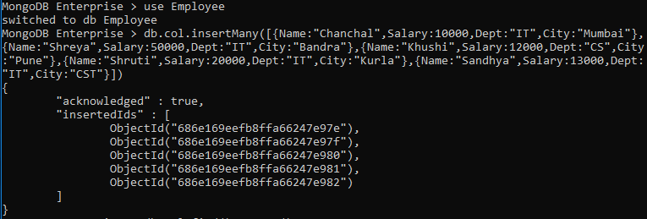

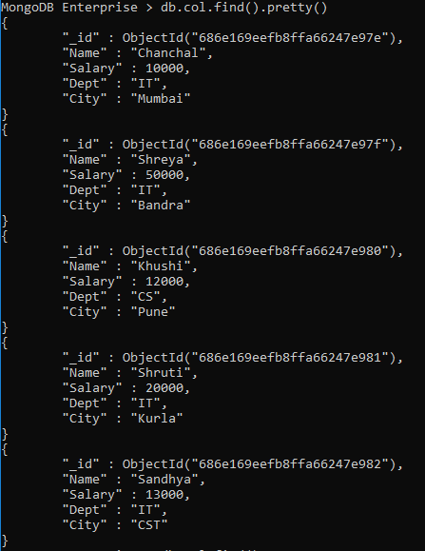

2) Display details of employees who live in Mumbai.

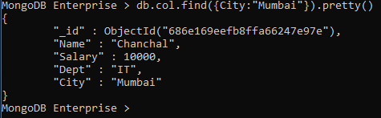

3) Display details of employee staying in Kurla and salary greater than 19000.

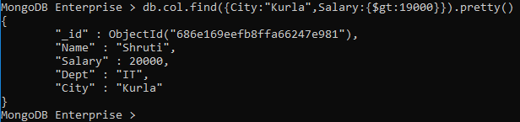

4) Display details of the employee whose salary is greater than equal 10000 but less than 11000.

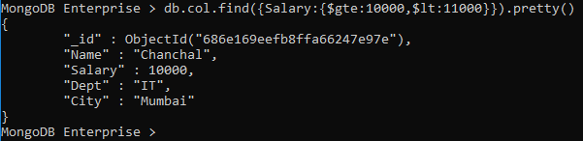

5) Display details of employee staying in either Pun e or Mumbai and salary greater than 10000.

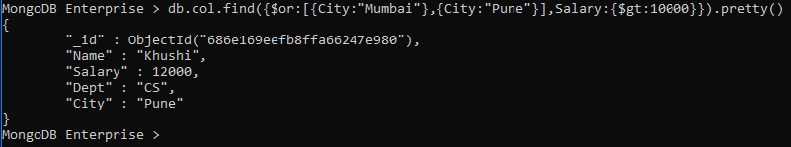

6) Display details of employee whose salary is not equal to 10000 and working in either developer or tester department.

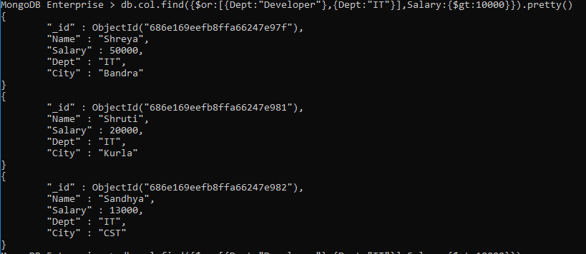

Importing JSON file in mongodb

Step 1: Open the first cmd in admin mode and type **mongod** command.

Step 1: Open the another cmd in admin mode and type **mongo** command.

Step 3: Create a new database and also create a collection in it.

**use database_name**

**db.createCollection(“collection_name”)**

Step 4: Open another cmd in admin mode and type

**mongoimport –db database_name –collection collection_name path_of_the_json_file**



Creating a backup copy of database

Type the following command to create backup of database

Step 1:

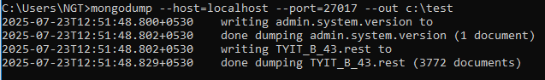

Step 2: Let us delete the existing database from mongodb through mongoshell by using following command

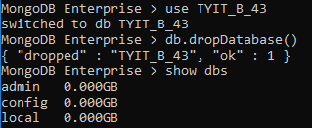

Step 3: Let us now use backup copy of drop database from the following command in new cmd

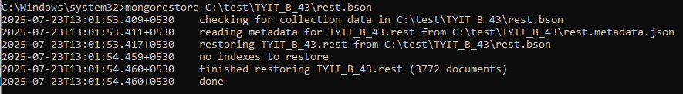

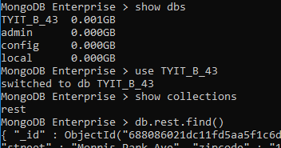

Questions:

1] Write a mongodb query to display all the documents in the collection resturants.

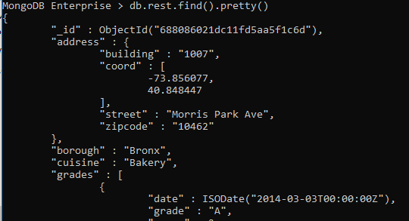

2] Write a mongodb query to display the fields restaurant_id, name, borough and cuisine for all the documents in the collection restaurant.

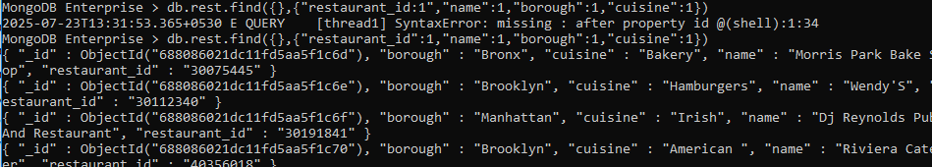

3] Write a MongoDB query to display the fields restaurant_id, name, borough and cuisine, but exclude the field_id for all the documents in the collection restaurant.

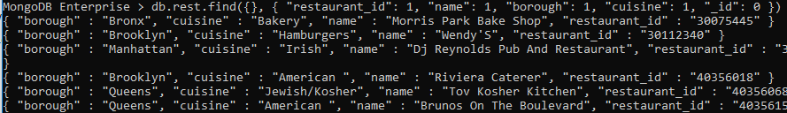

4] Write a MongoDB query to display the fields restaurant_id, name, borough and zip code, but exclude the field_id for all the documents in the collection restaurant.

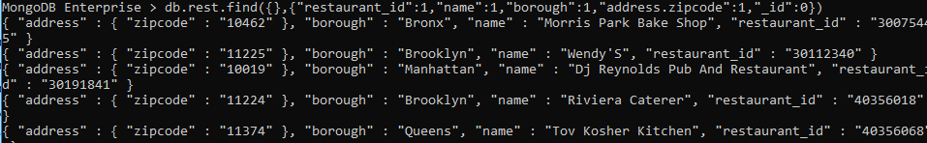

5] Write a MongoDB query to display all the restaurant which is in the borough Bronx.

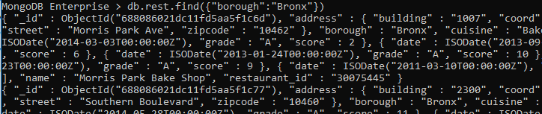

6] Write a MongoDB query to display the first 5 restaurant which is in the borough Bronx.

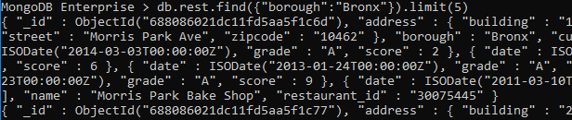

7] Write a MongoDB query to display the next 5 restaurants after skipping first 5 which are in the borough Bronx.

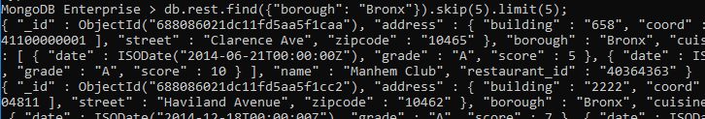

8] Write a MongoDB query to find the restaurants who achieved a score more than 90.

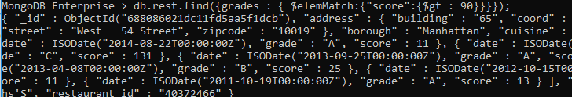

9] Write a MongoDB query to find the restaurants that achieved a score, more than 80 but less than 100.

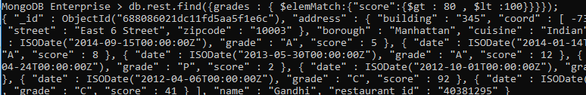

10] Write a MongoDB query to find the restaurants which locate in latitude value less than 95.754168.

